* **Sequence 1**

**Task Number - AX**

**For the following you will assemble the following. All of the required parts should already be present in front of you. Nevertheless, always be aware of your surroundings and the robot.**

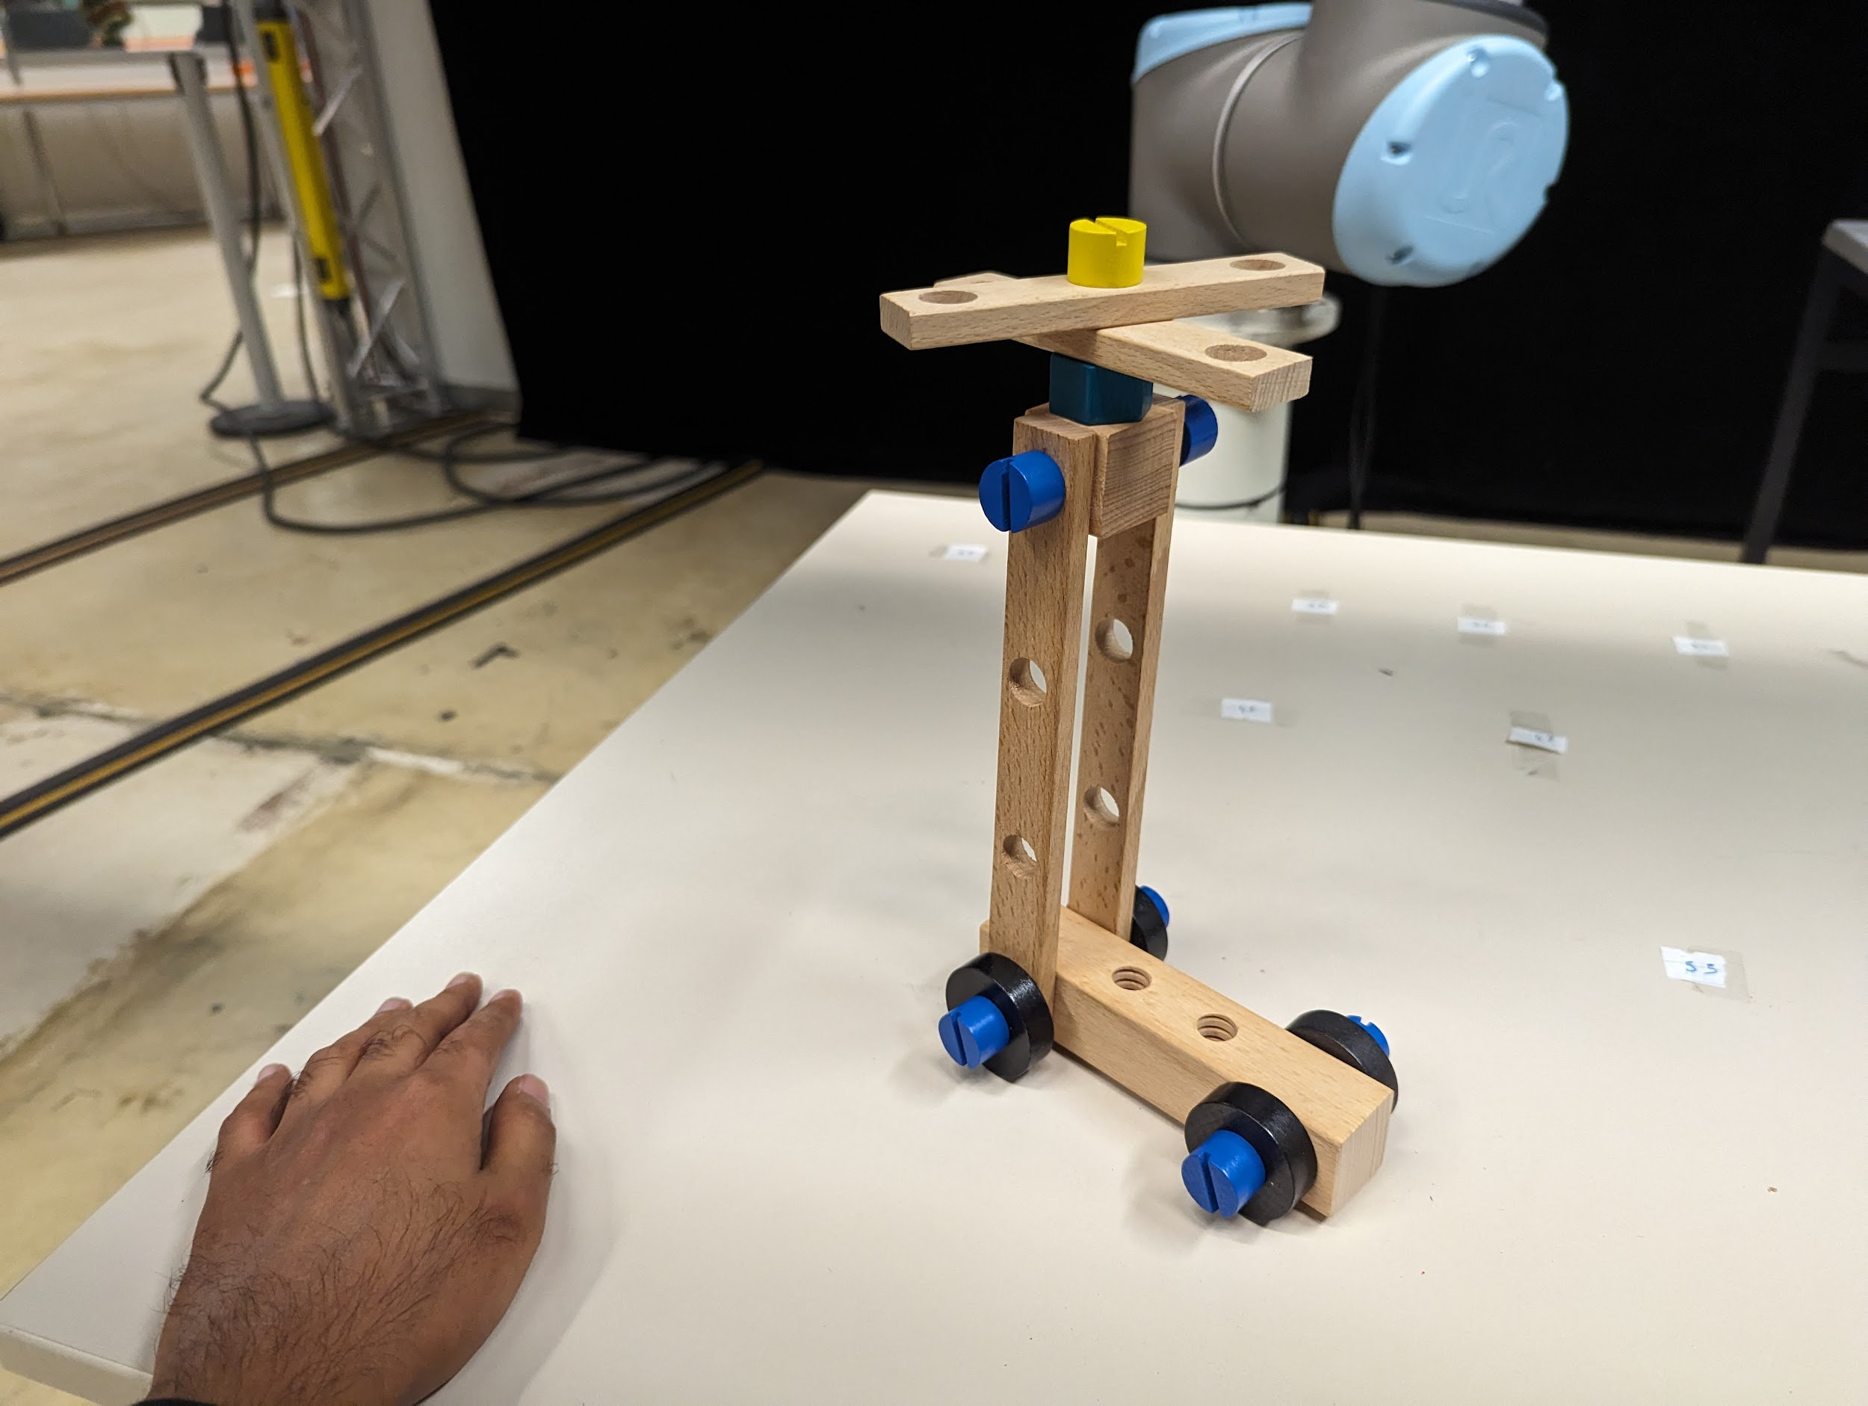

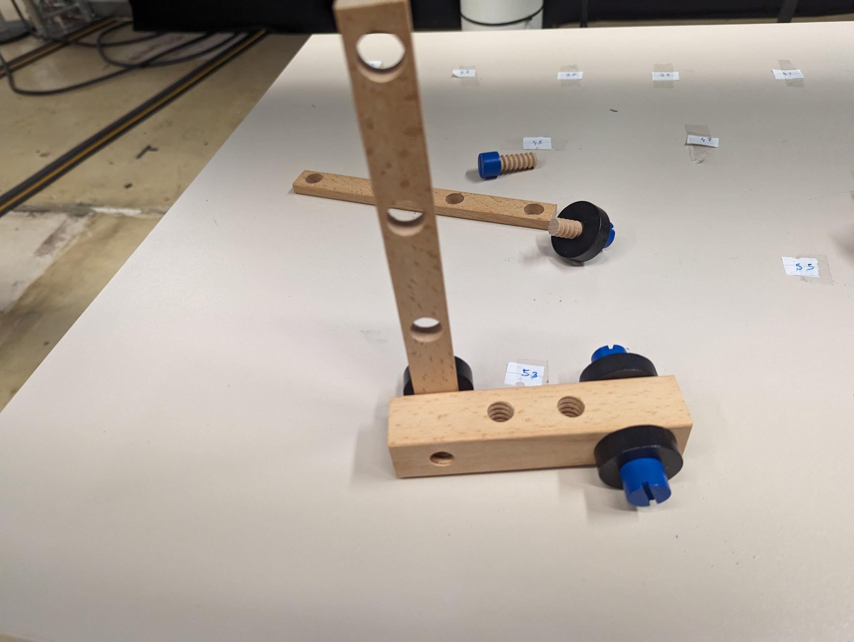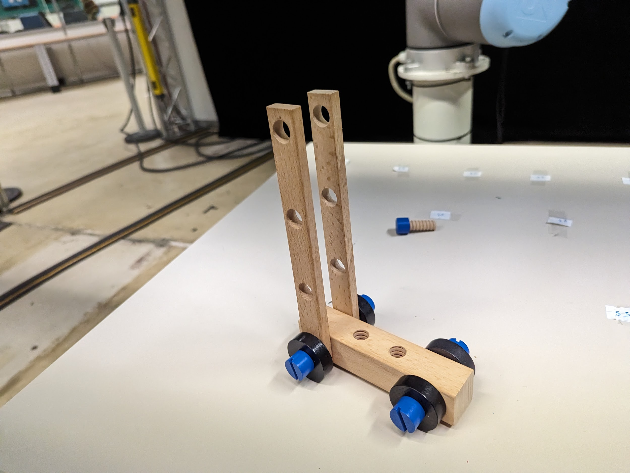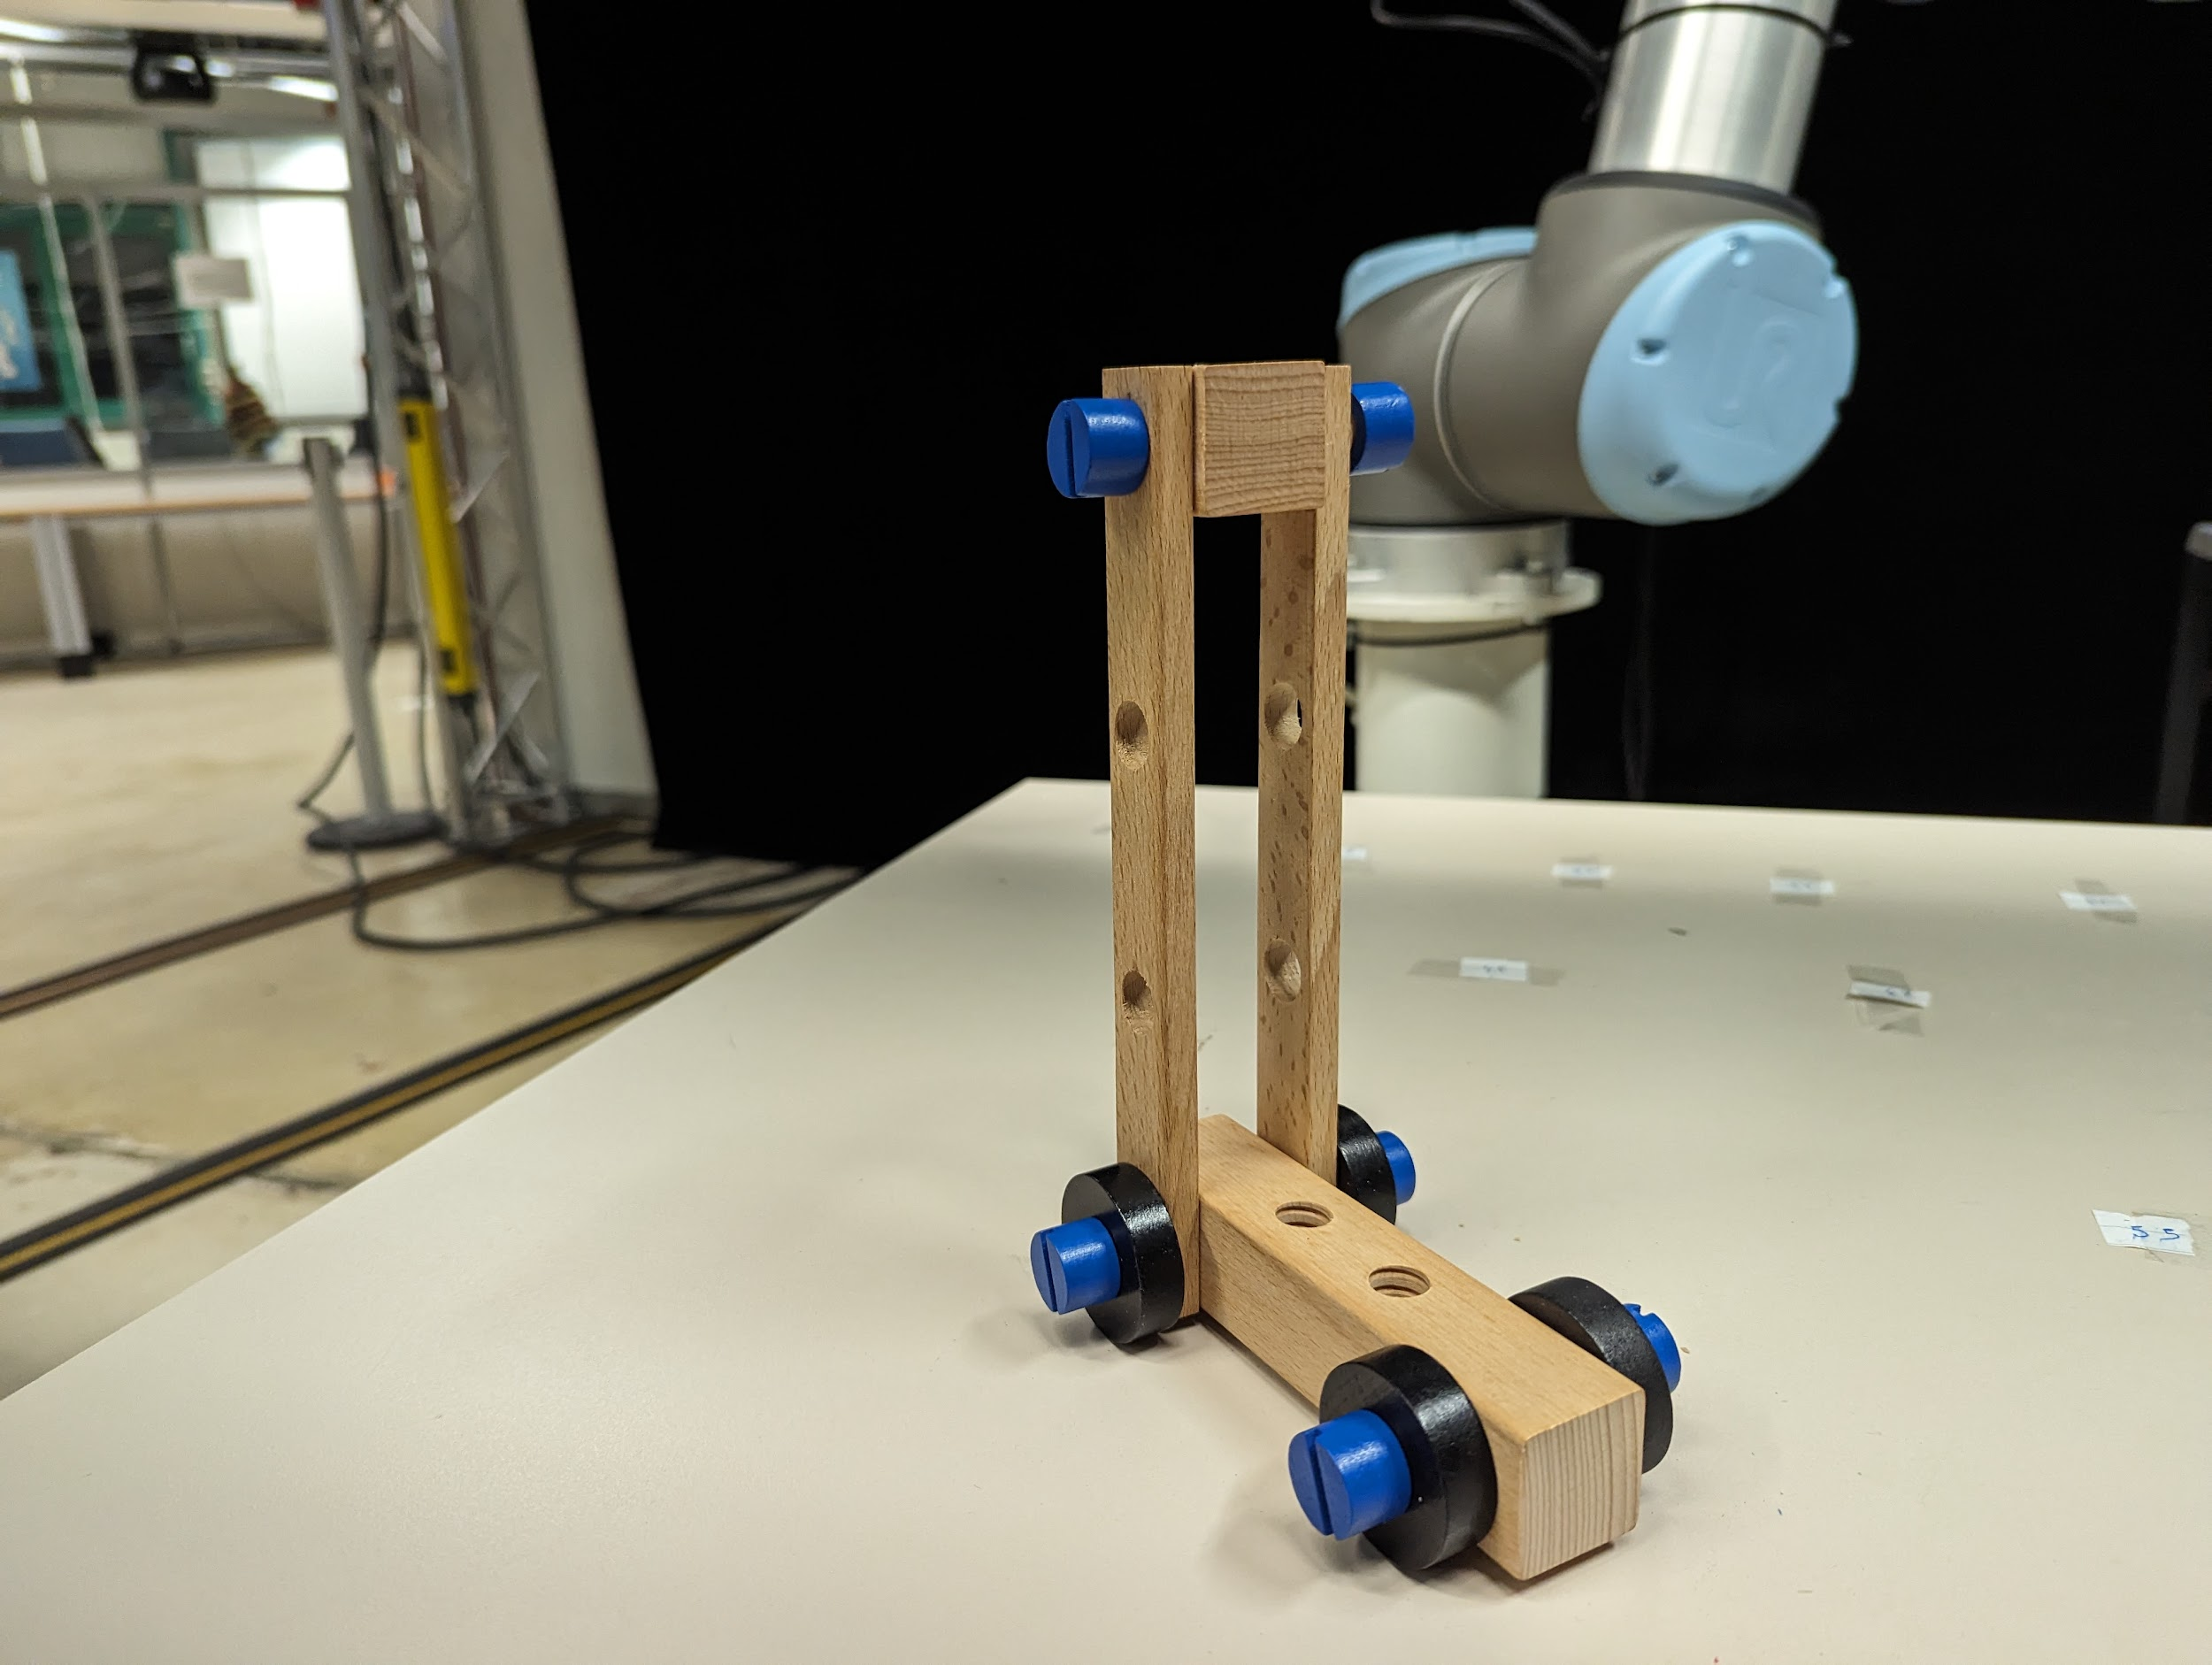

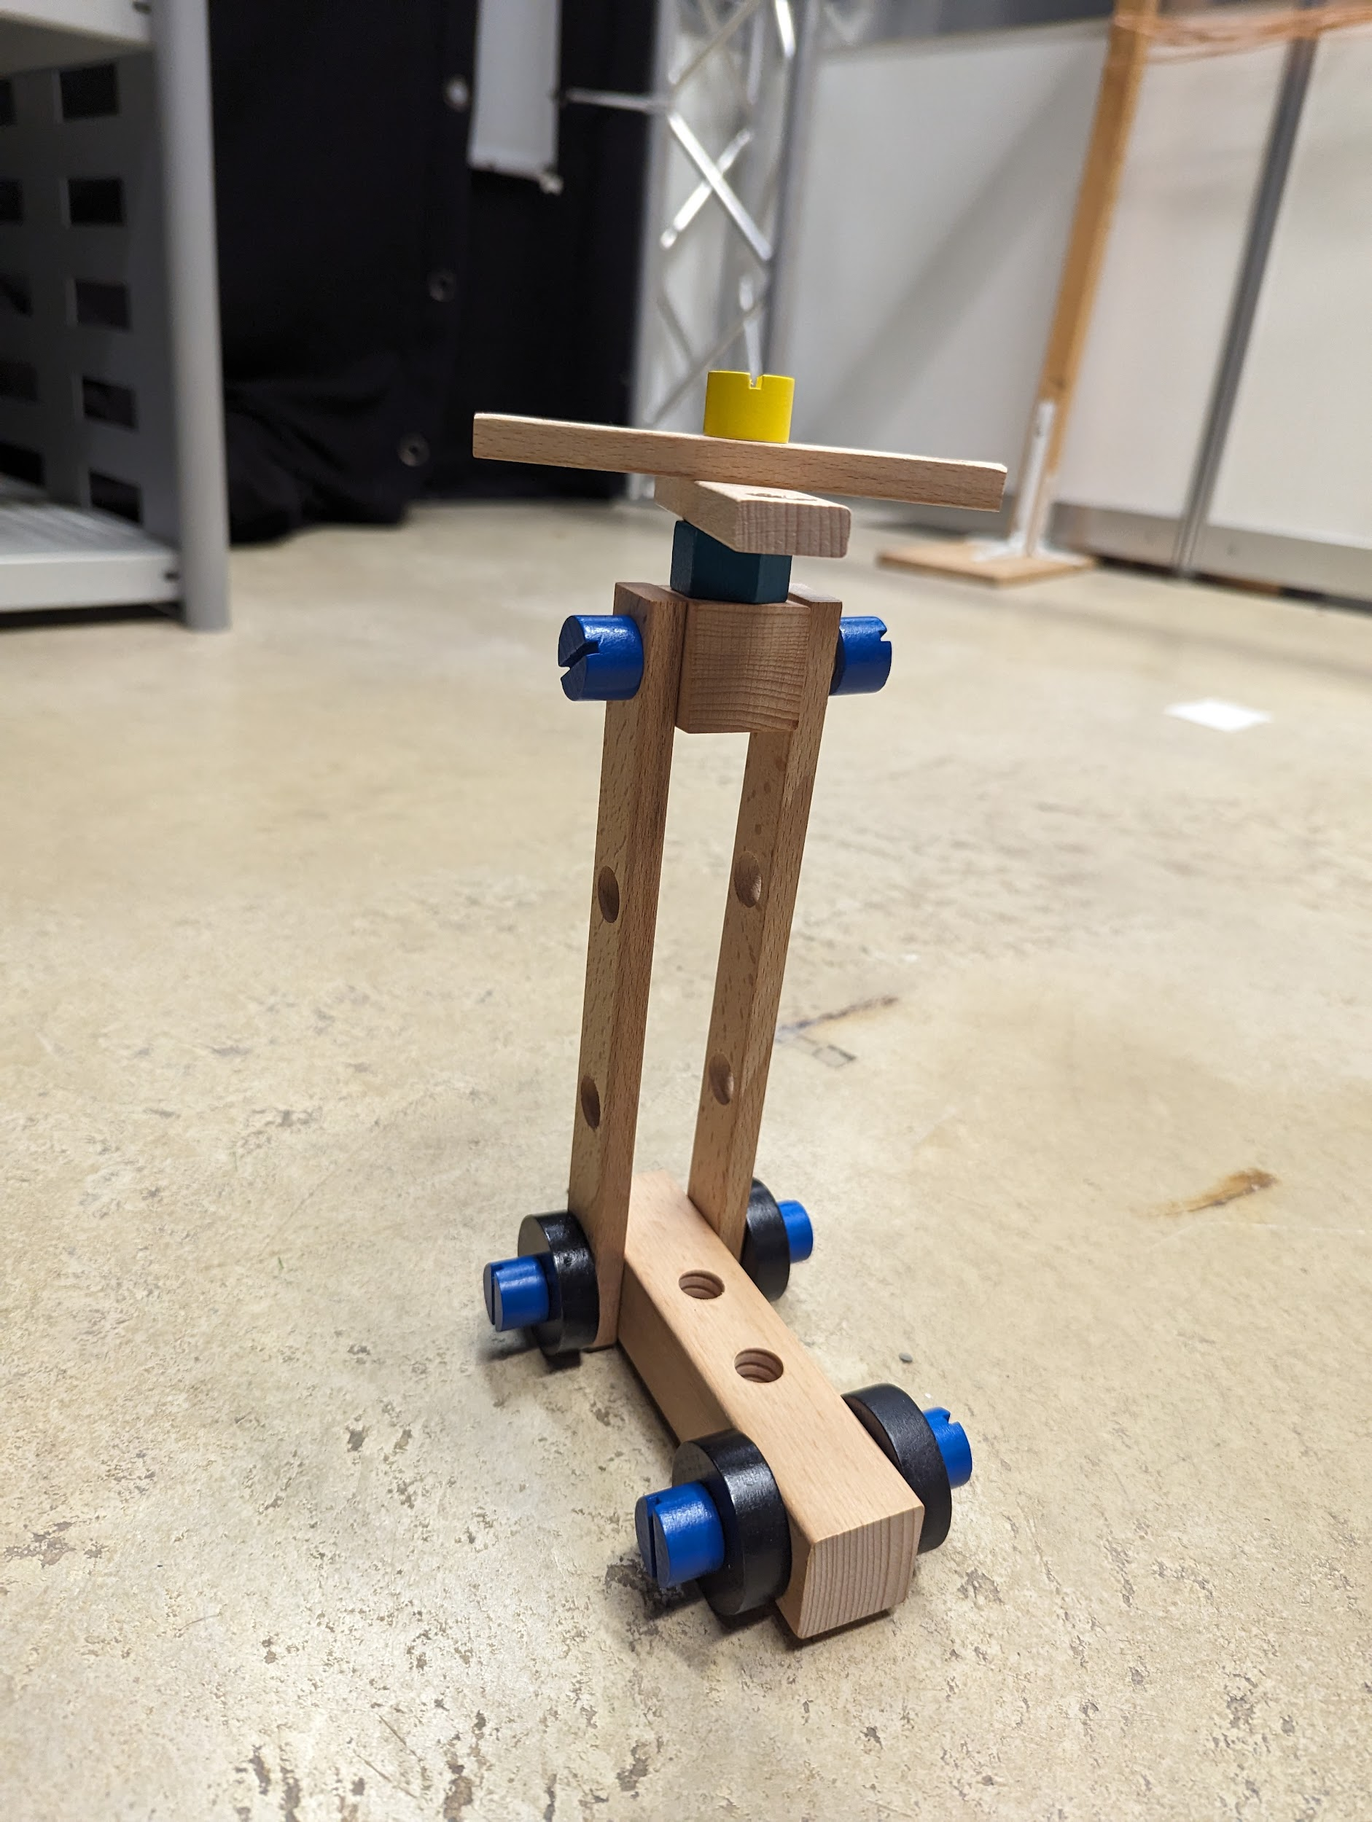

**After Completion of the task please let the in-charge know and fill the given questionnaire below related to the task .**

[**NASA-TLX Questionnaire( Expermient Id : AX)**](https://nasa-tlx.firebaseapp.com/tlx)

[**SAM-AX**](https://forms.gle/LqtVKVqfRDZPtJYu5)

**Task Number BX**

For this task you will be assembling the following. You can follow the step by step guide below if you need any help.

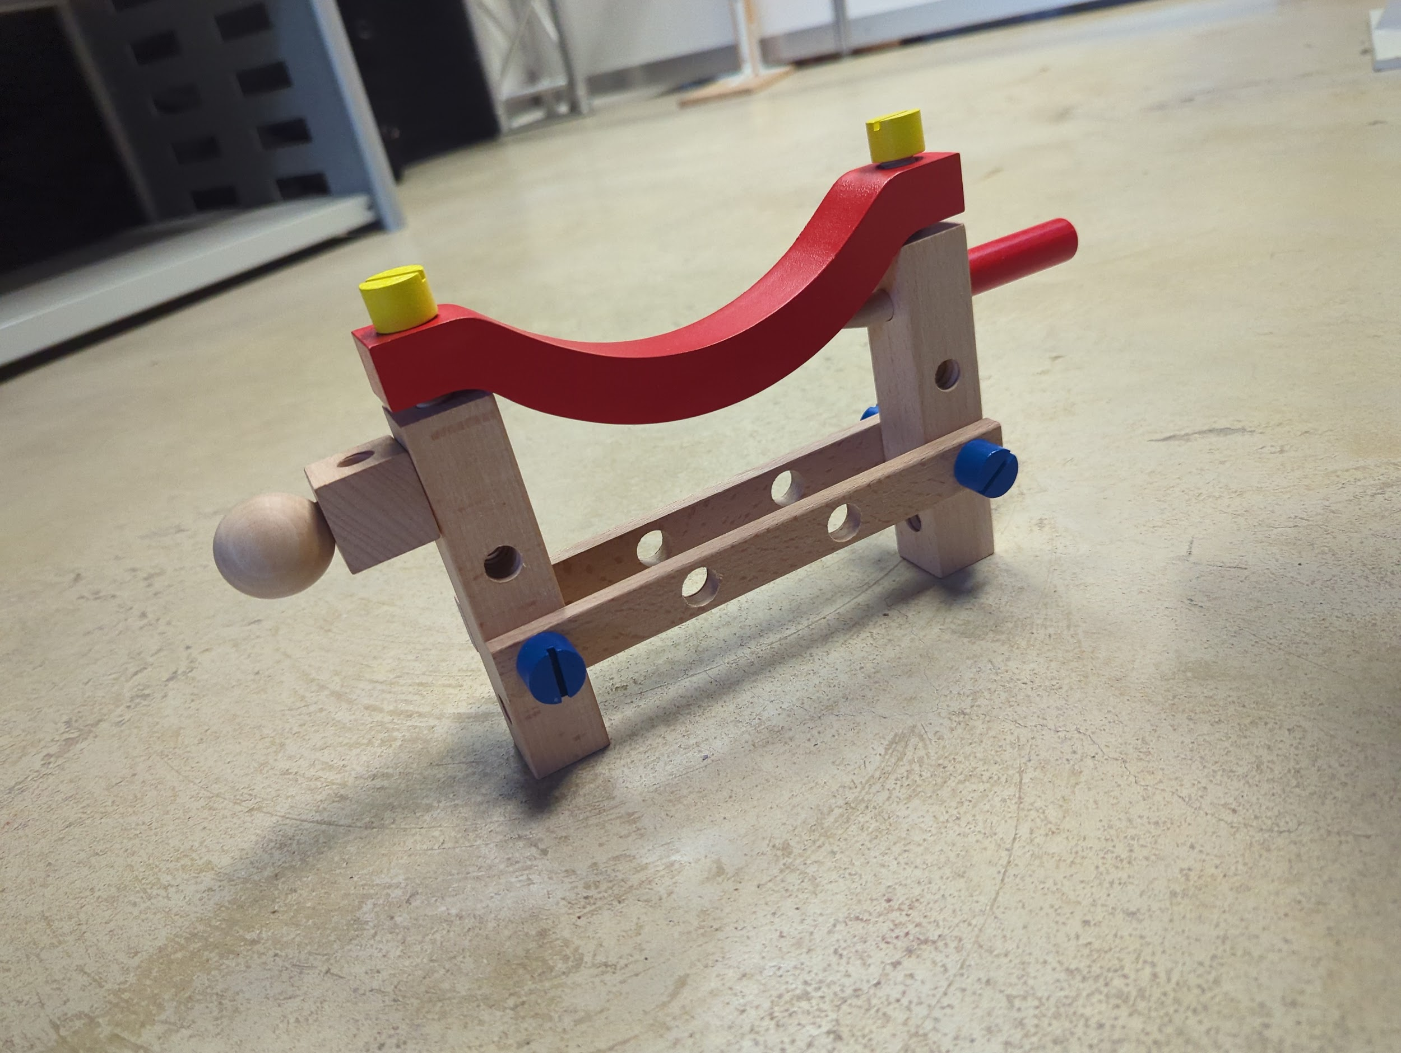

Please note all the items you need will be brought by the robot or already be present in front of you. Except the following part : 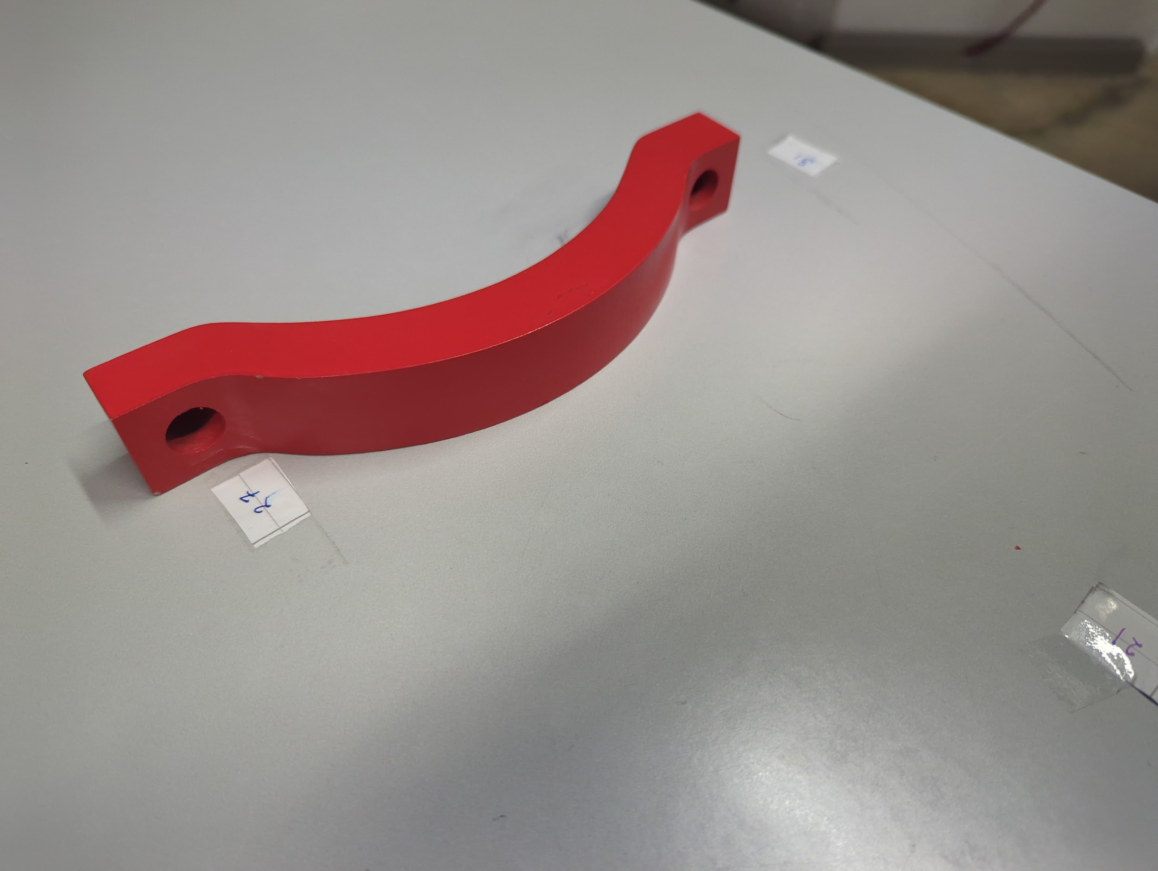

Please reach out to the other table to get this part after the task has started and anytime after the first item has been delivered to you.

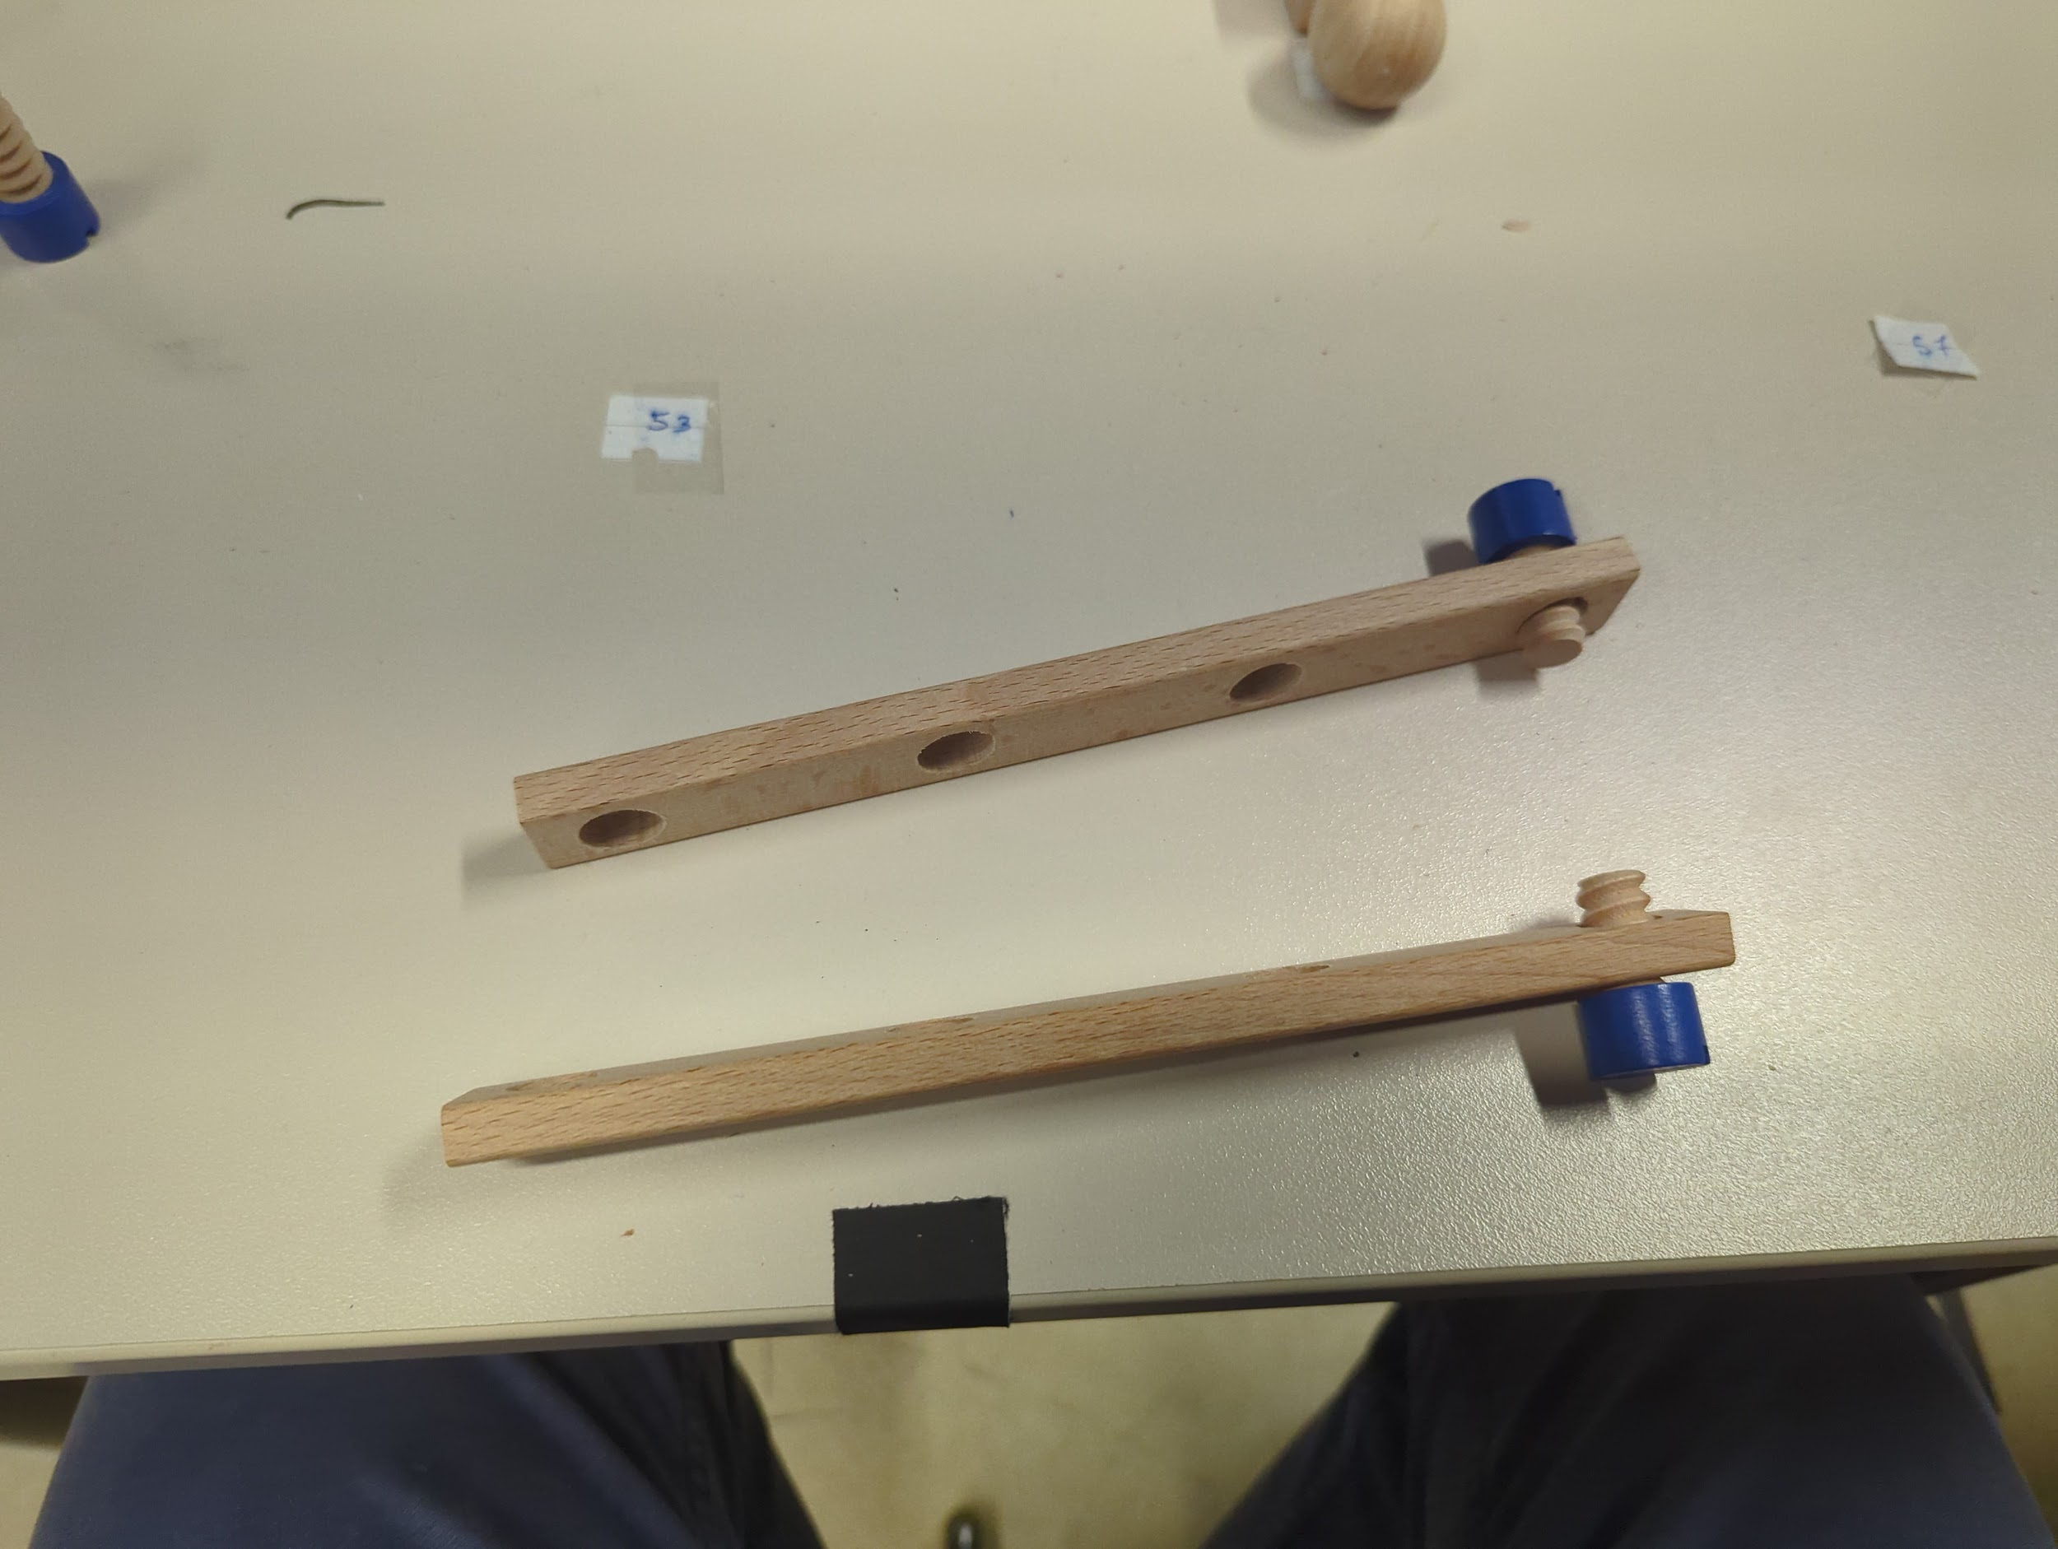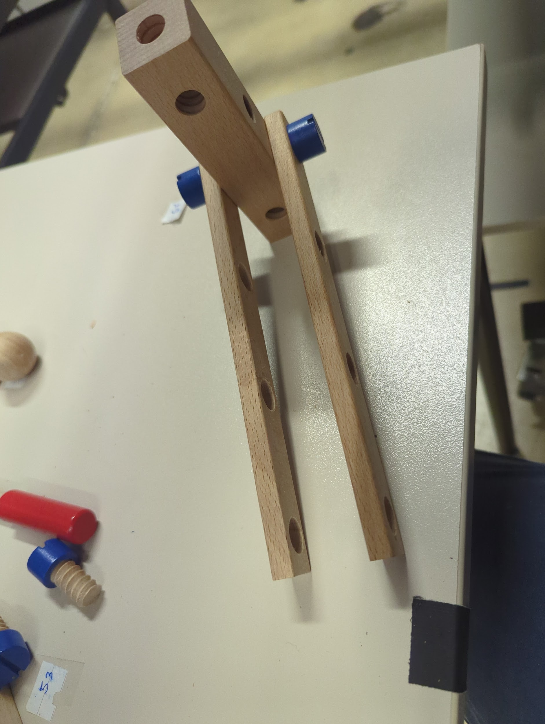

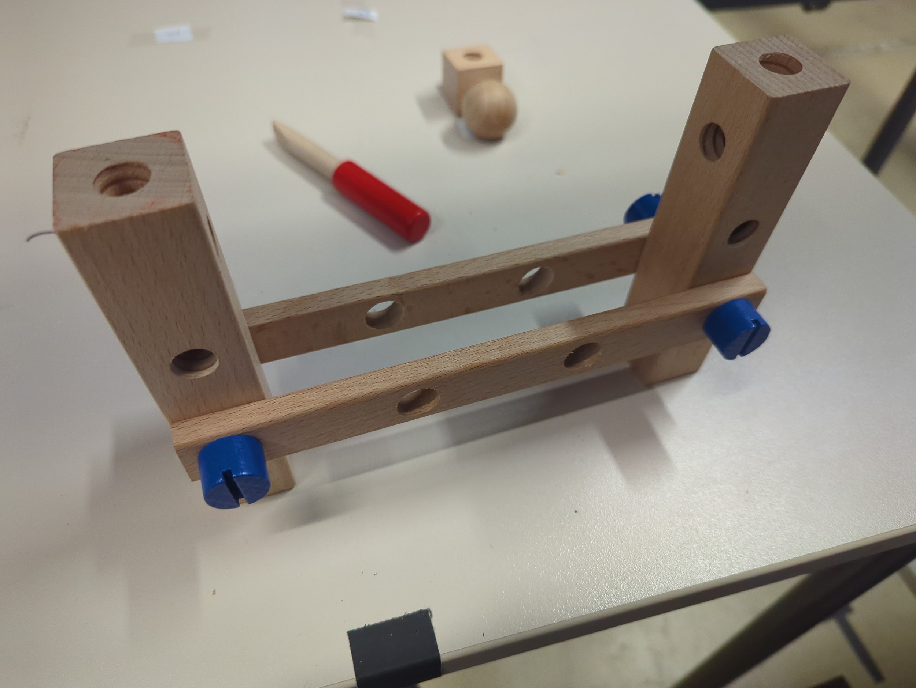

Make sure there are holes facing upwards on both rectangular boxes. Reach out for the top part..and finish the assembly as shown.



**After Completion of the task please fill the given questionnaire below related to**

**the task .**

[**NASA-TLX Questionnaire( Expermient Id : BX)**](https://nasa-tlx.firebaseapp.com/tlx)

[**SAM-BX**](https://forms.gle/jvkj72mLBP1gcWS26)

**CX**

Next we will continue to this assembly. In this section the robot will not place the item in front of you but you will have to take the item directly from the gripper.

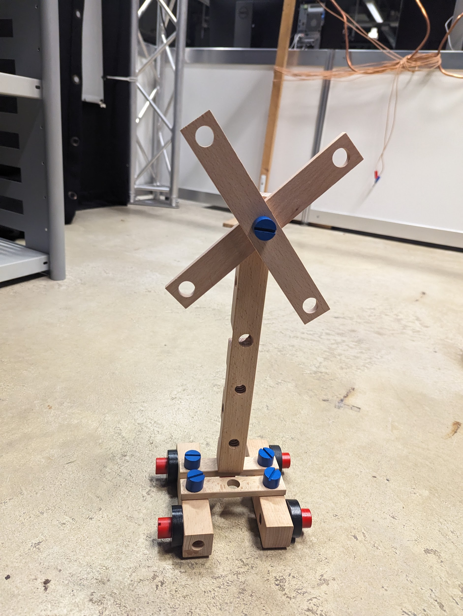

Please note all the items you need will be brought by the robot or already be present in front of you.

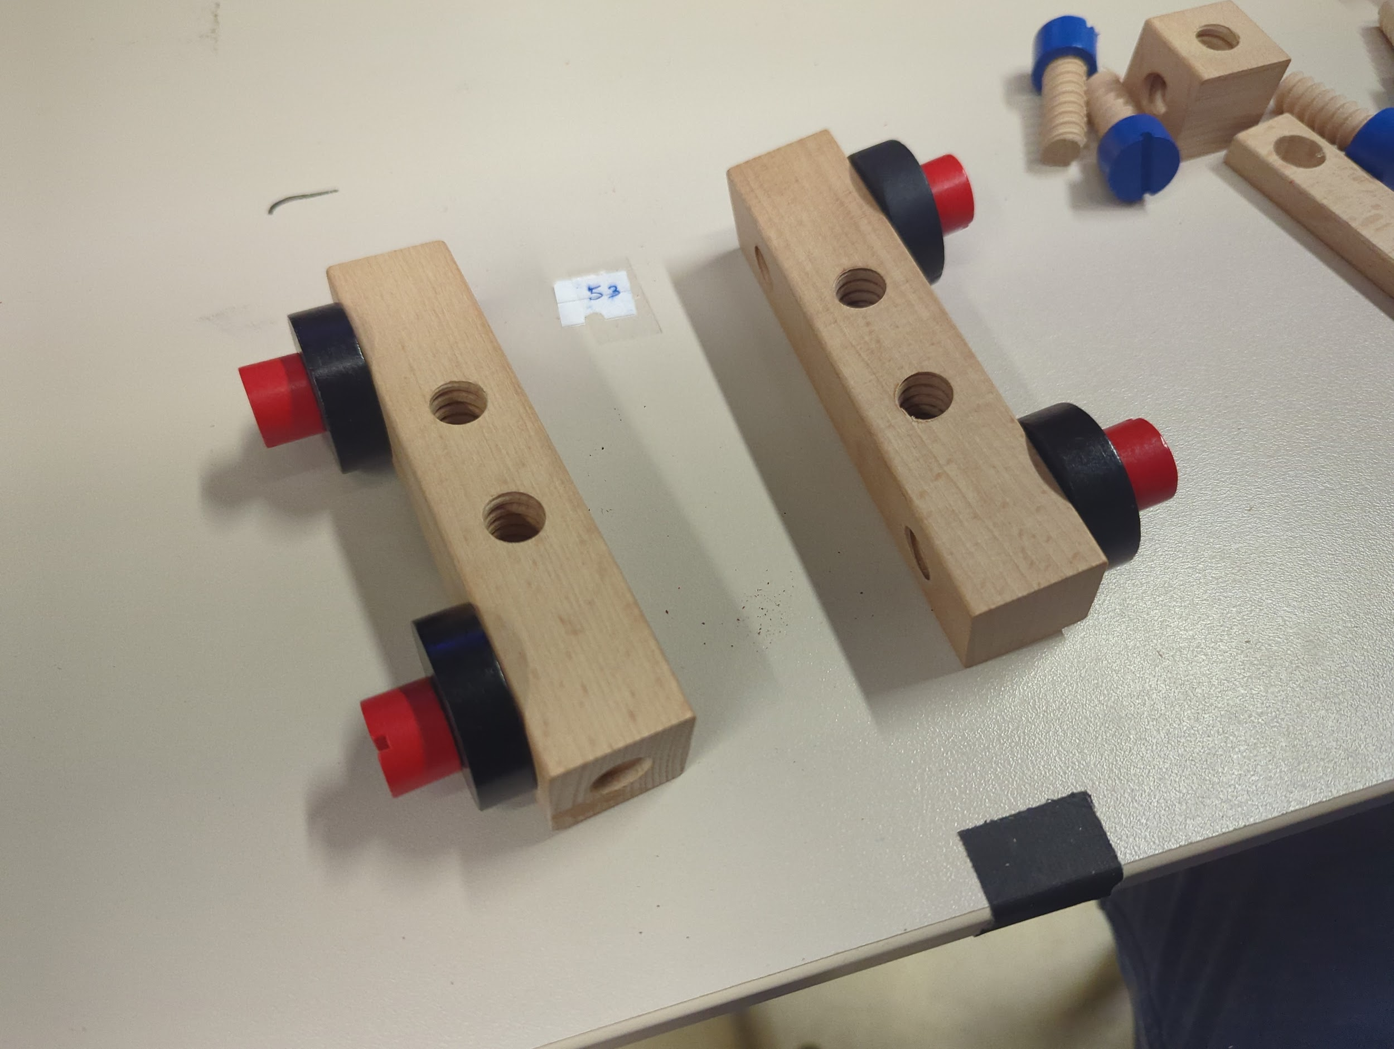

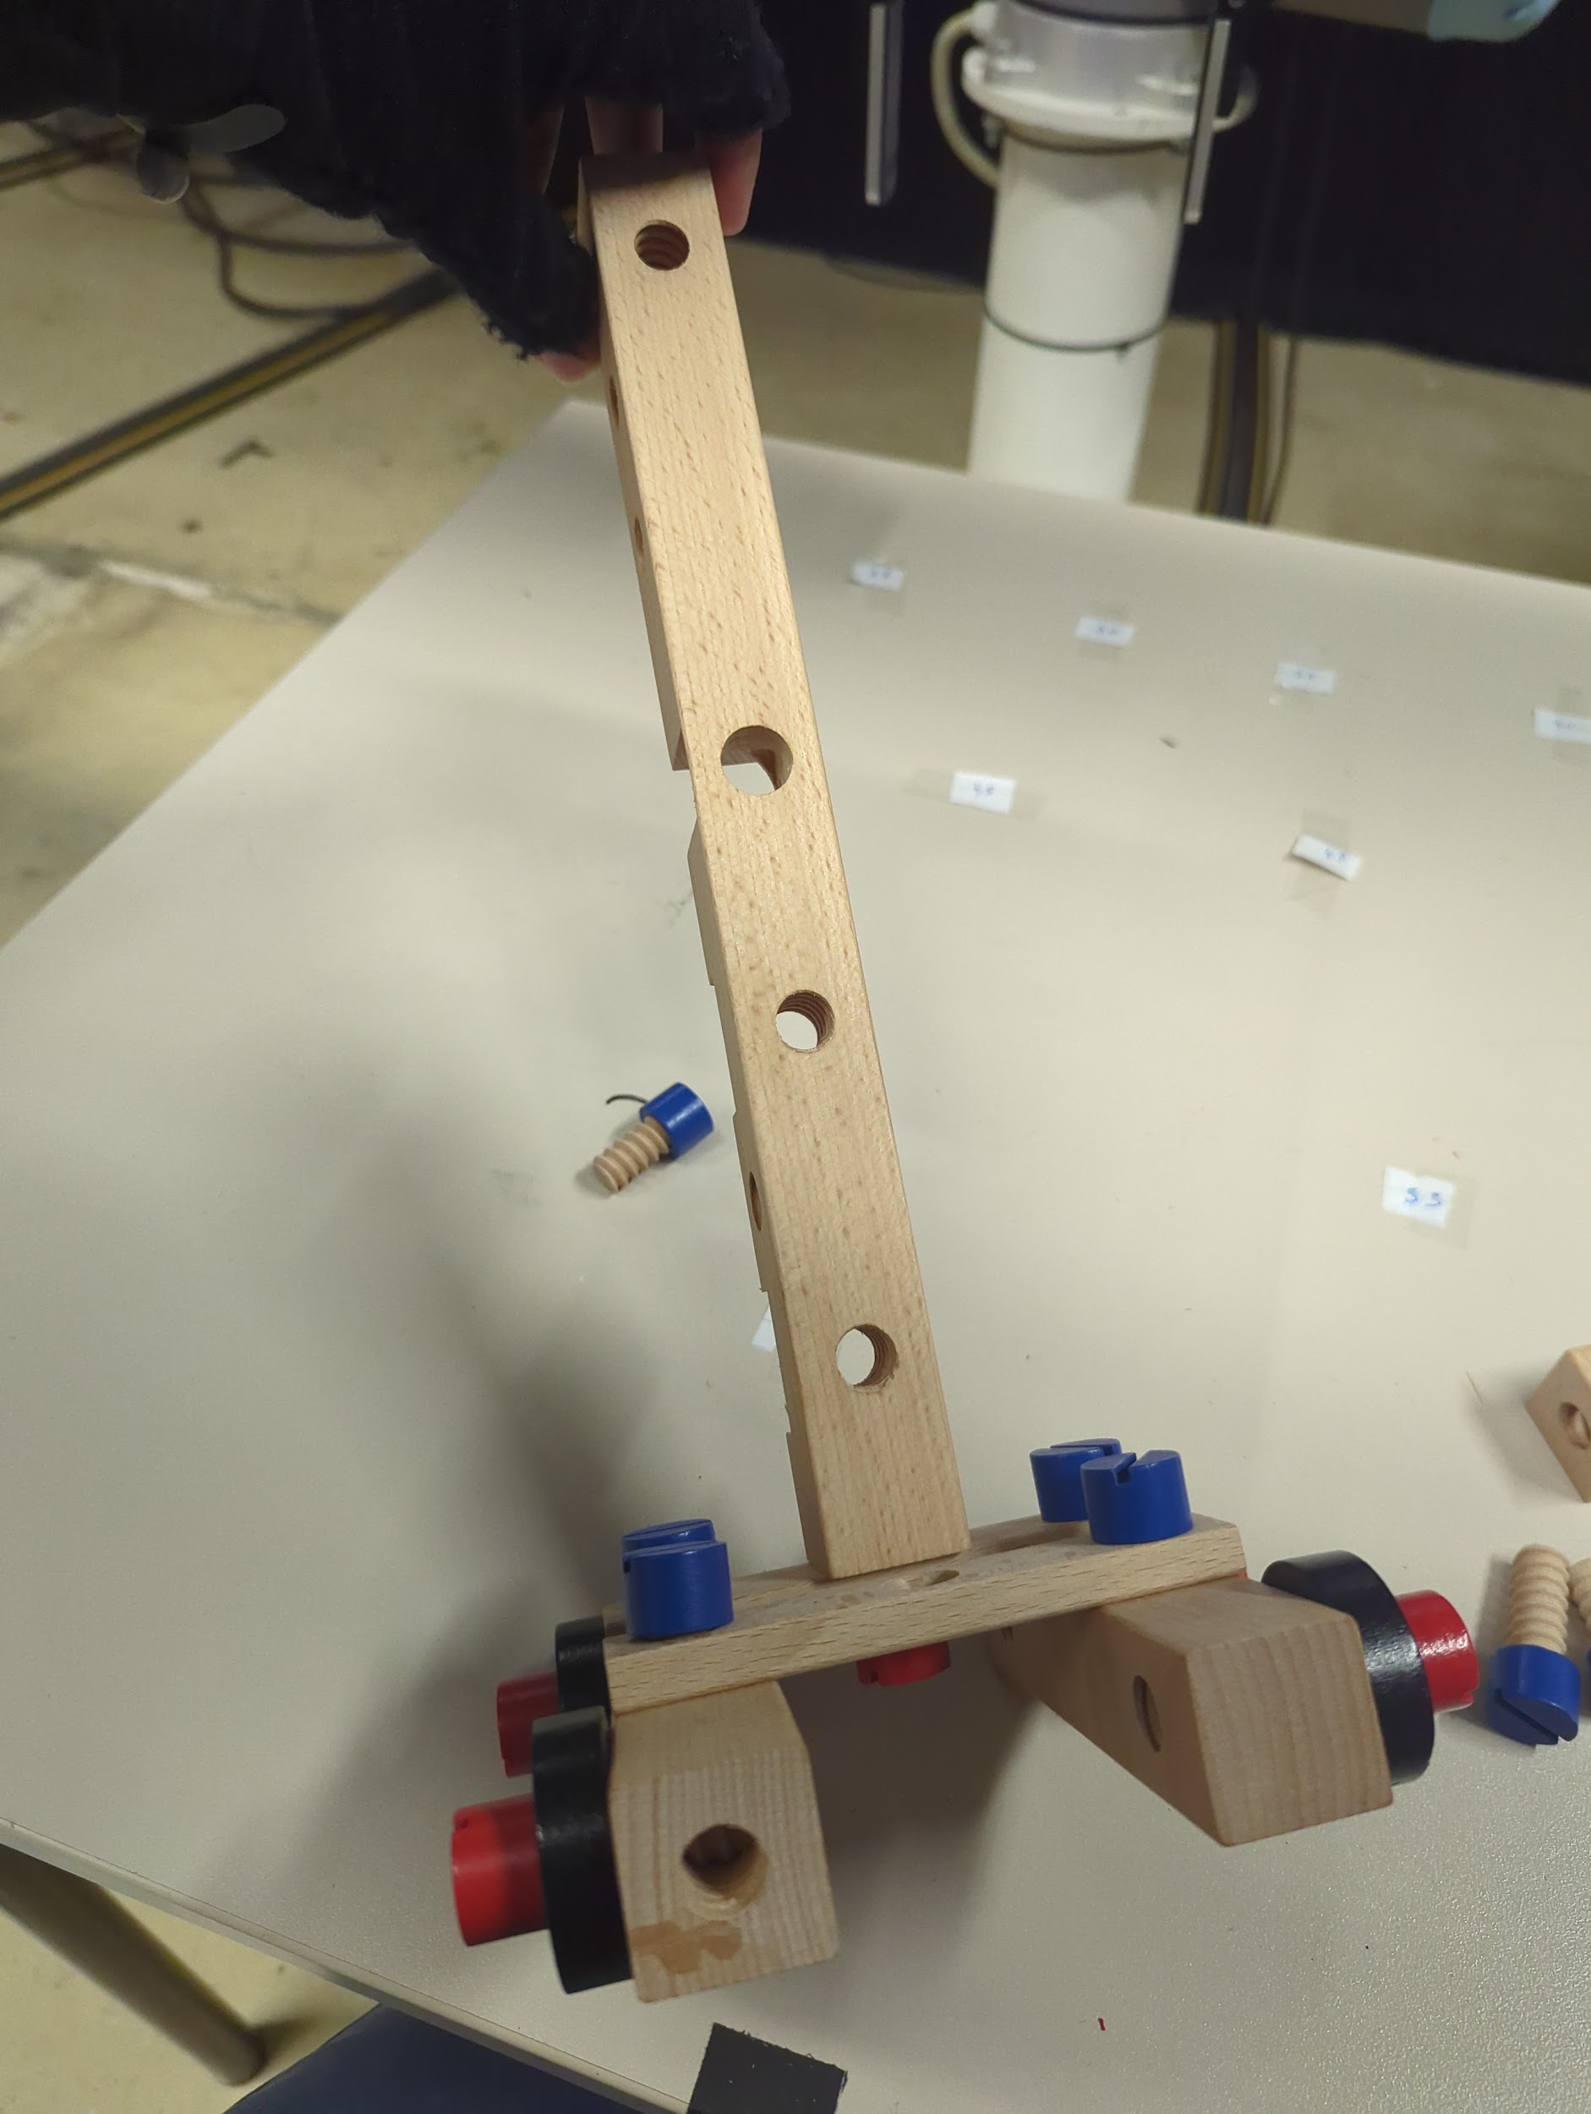

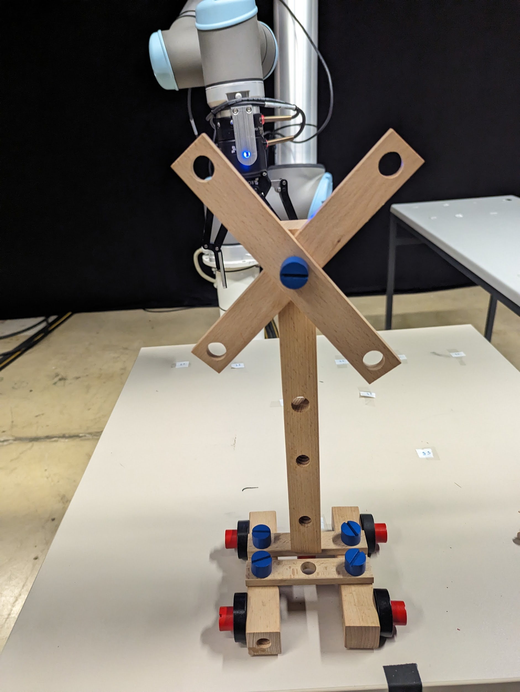

**After Completion of the task please fill the given questionnaire below related to the task .**

[**NASA-TLX Questionnaire( Expermient Id : CX)**](https://nasa-tlx.firebaseapp.com/tlx)

[**SAM-CX**](https://forms.gle/uPUvVv2ECHwJzro17)

**Task Number BY**

For this task you will be assembling the following. You can follow the step by step guide below if you need any help.

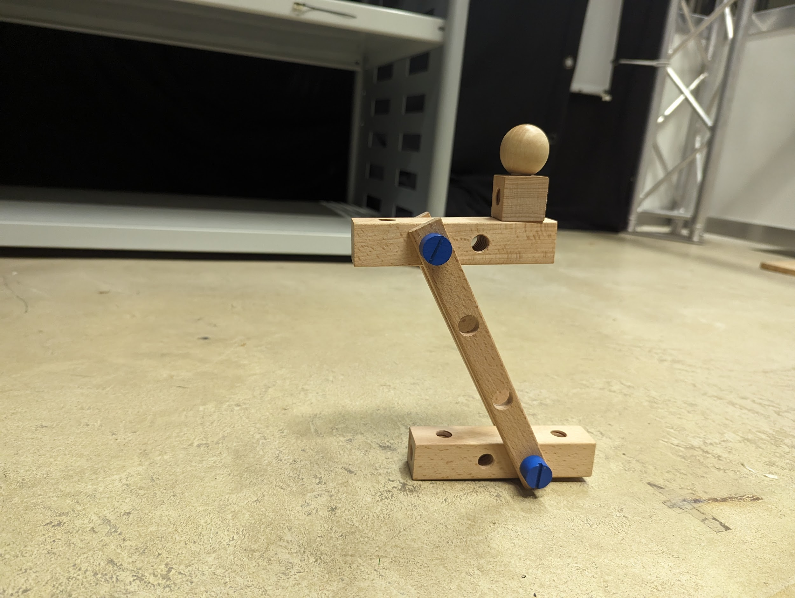

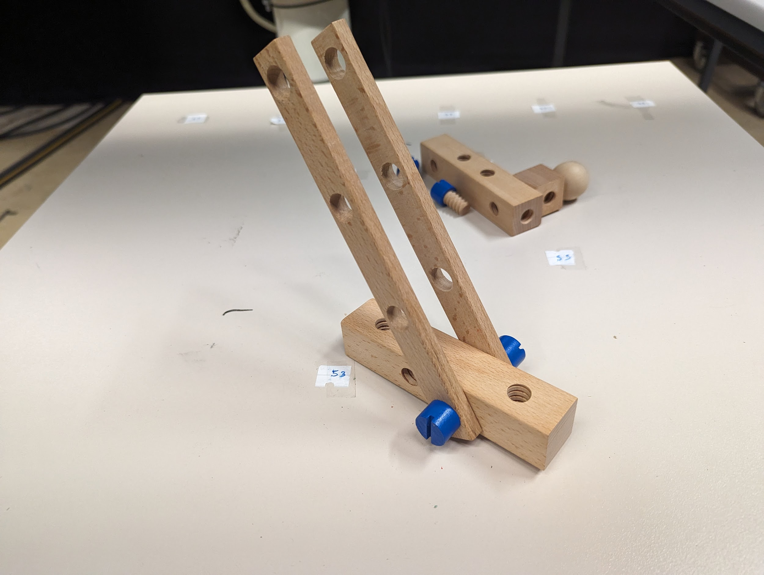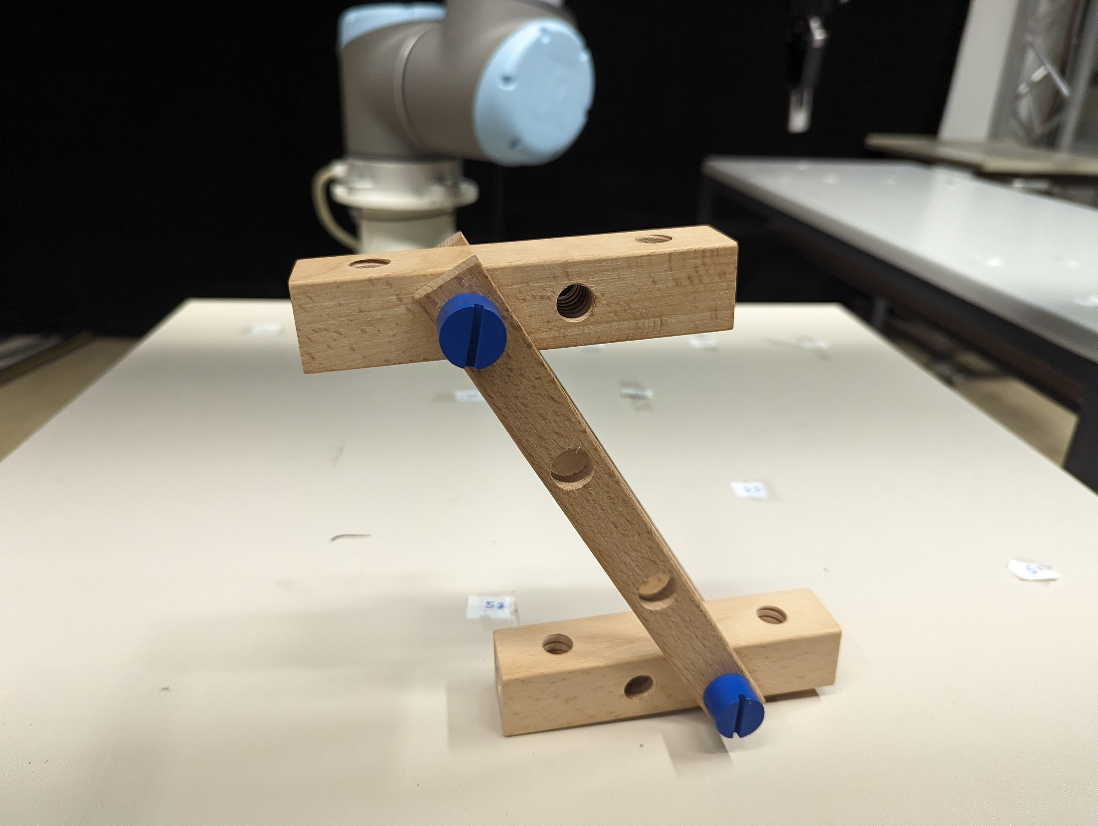

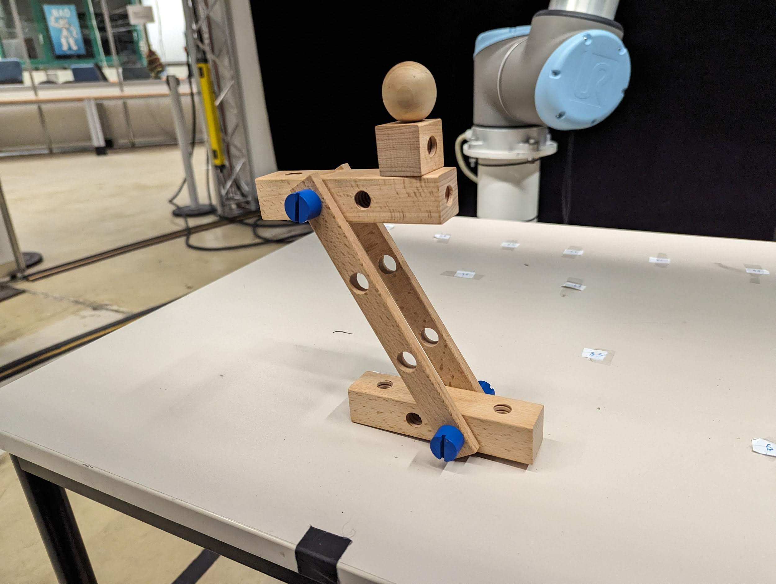

**After Completion of the task please let the in-charge know and fill the given questionnaire below related to the task .**

[**NASA-TLX Questionnaire( Expermient Id : BY)**](https://nasa-tlx.firebaseapp.com/tlx)

[**SAM-BY**](https://forms.gle/NGtEncHbHSAACnrH8)

Task Number CY

Next we will continue to this assembly. In this section the robot will not place the item in front of you but you will have to take the item directly from the gripper.

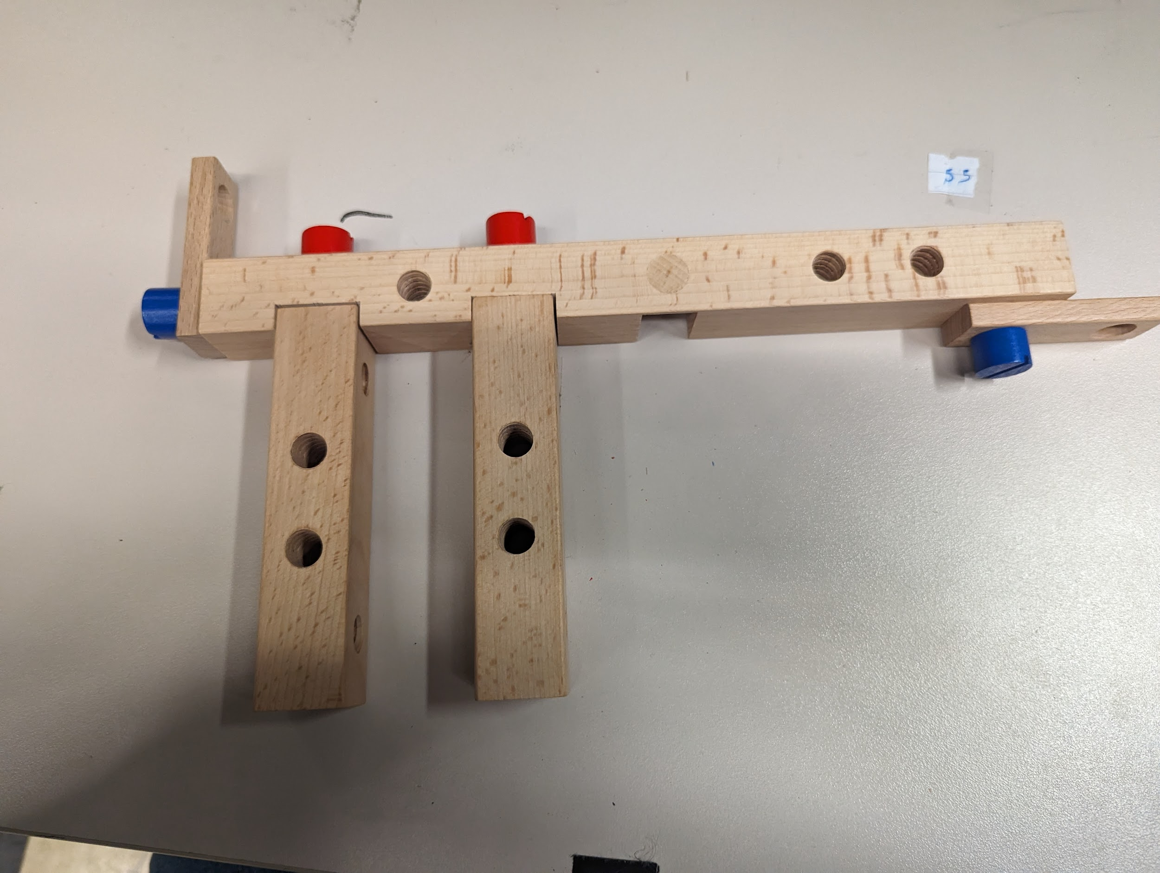

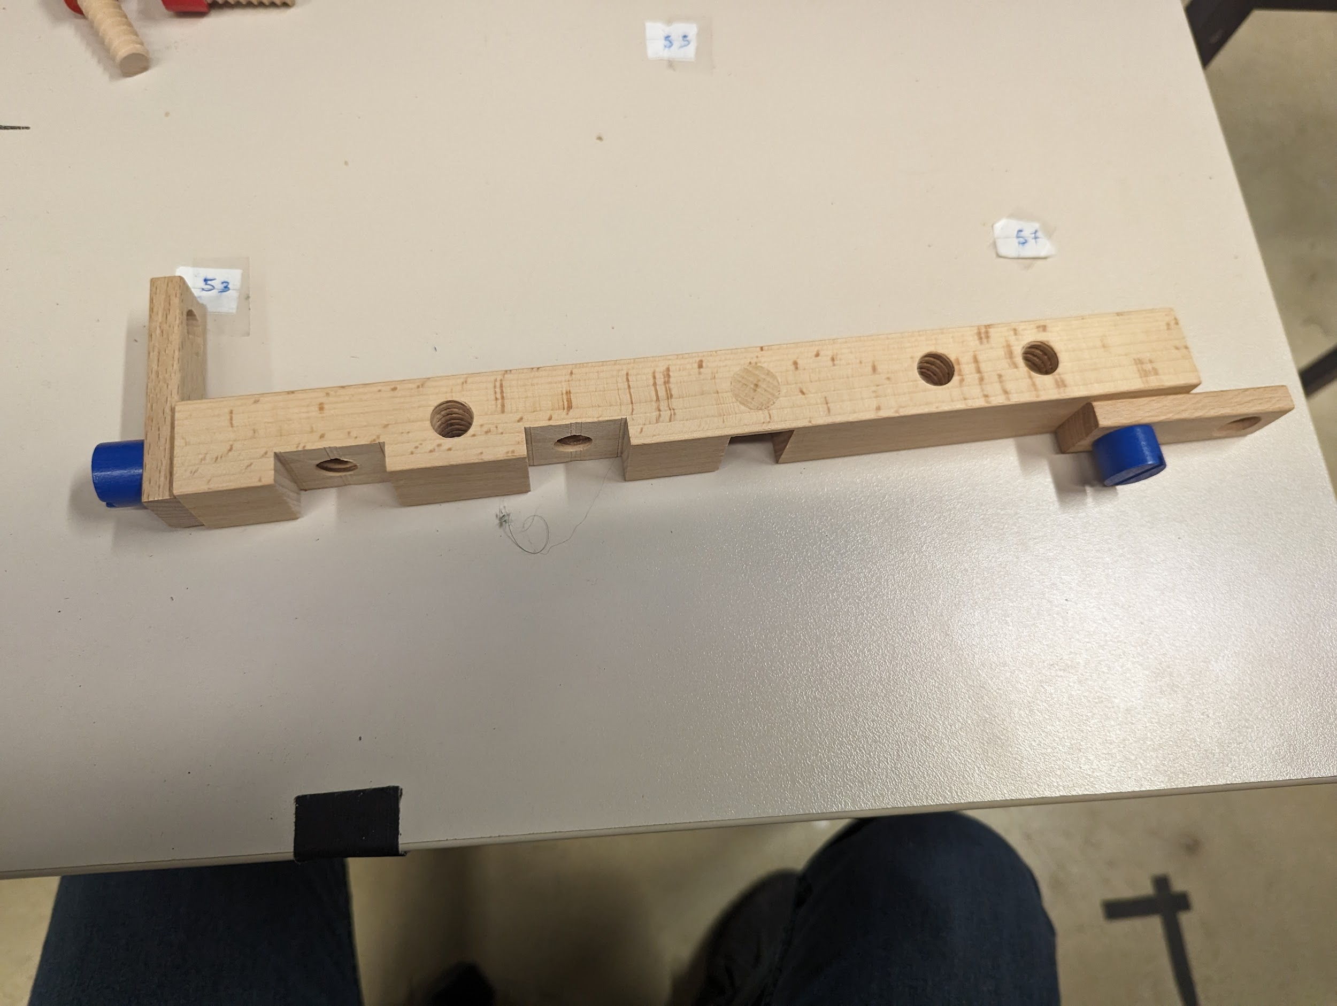



**After Completion of the task please let the in-charge know and fill the given questionnaire below related to the task .**

[**NASA-TLX Questionnaire( Expermient Id : CY)**](https://nasa-tlx.firebaseapp.com/tlx)

[**SAM-CY**](https://forms.gle/jr87rkaD3ET1NwVE8)

**Task Number BZ**

For this task you will be assembling the following. You can follow the step by step guide below if you need any help.

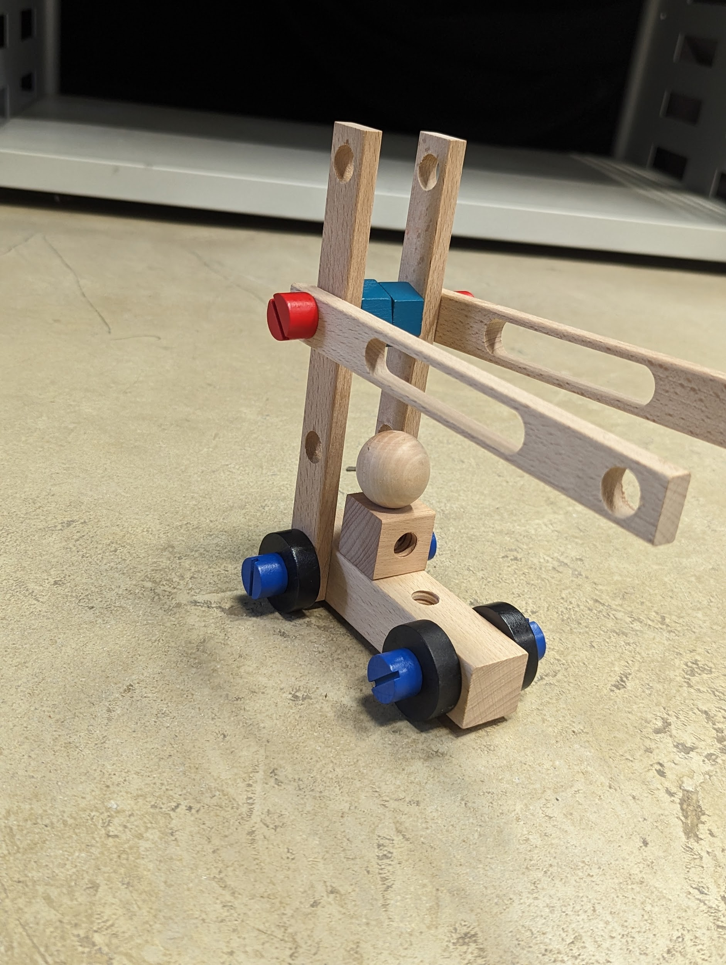

**After Completion of the task please let the in-charge know and fill the given questionnaire below related to the task .**

[**NASA-TLX Questionnaire( Expermient Id : BZ)**](https://nasa-tlx.firebaseapp.com/tlx)

[**SAM-BZ**](https://forms.gle/CqkxoEFSNUDqvXTh7)

**Task Number CZ**

Next we will continue to this assembly. In this section the robot will not place the item in front of you but you will have to take the item directly from the gripper.

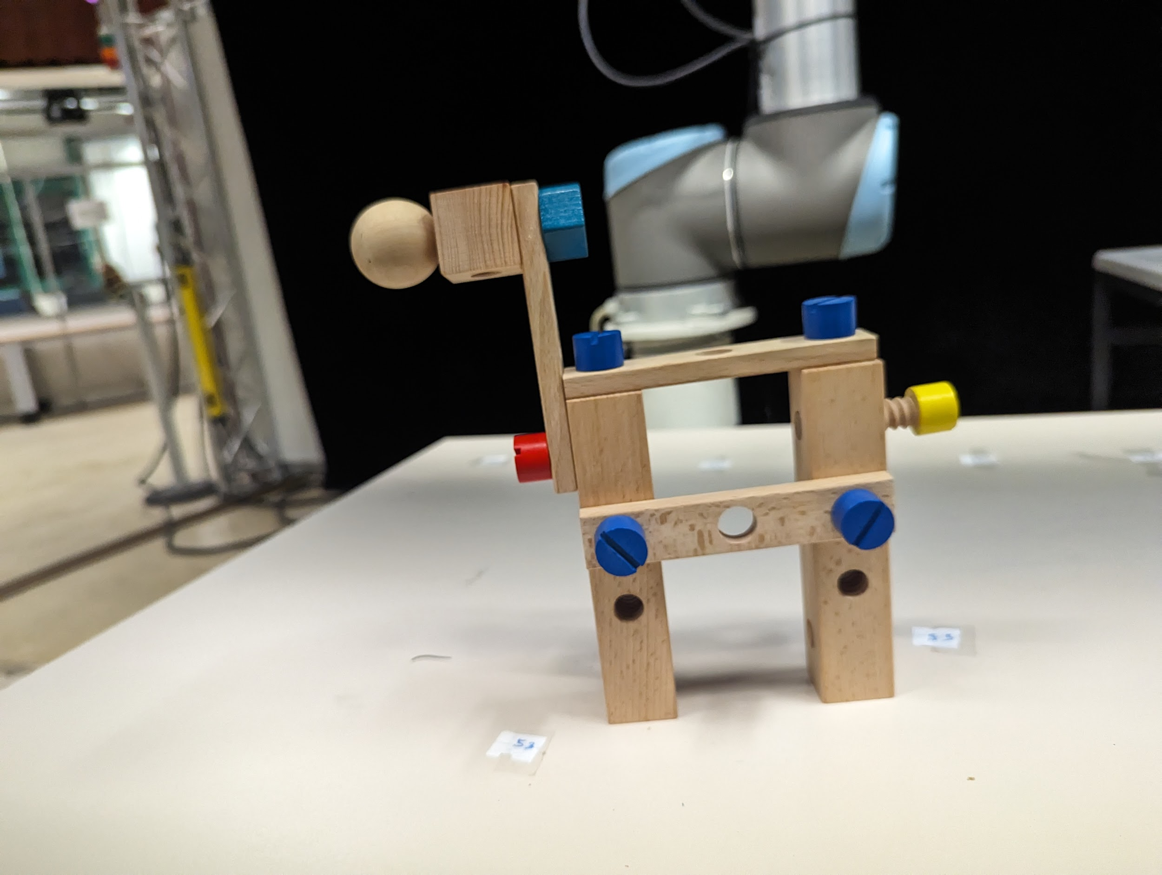

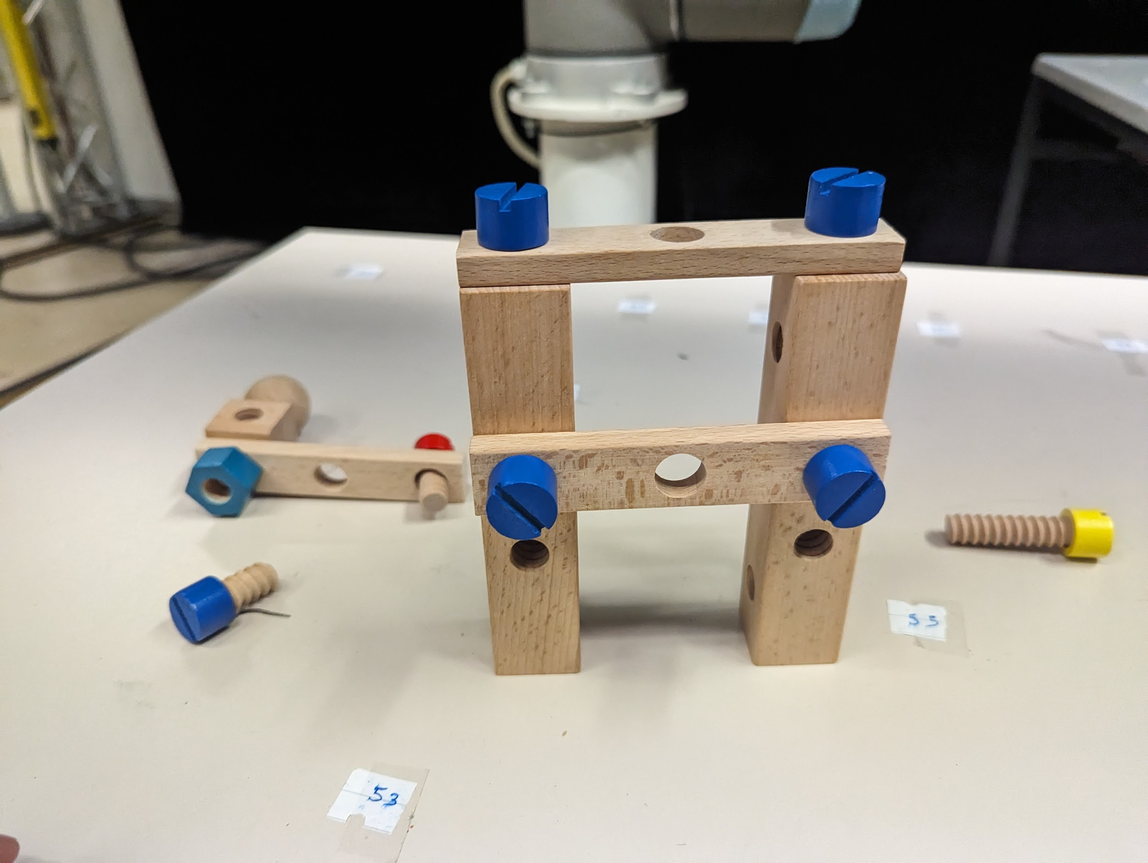

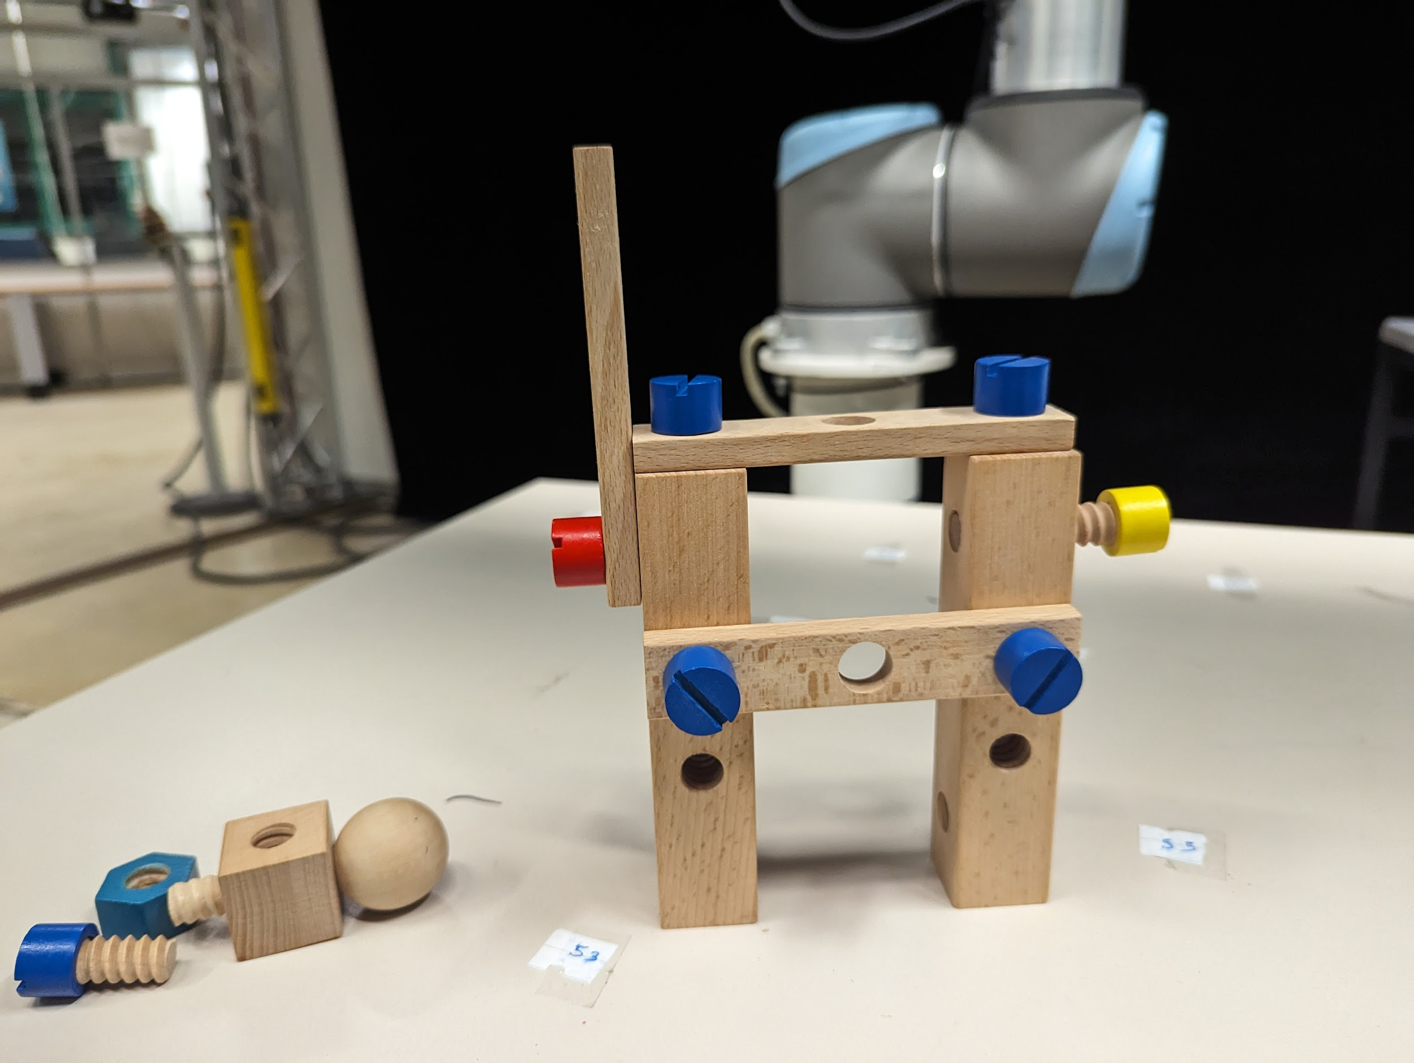



**After Completion of the task please let the in-charge know and fill the given questionnaire below related to the task .**

[**NASA-TLX Questionnaire( Expermient Id : CZ)**](https://nasa-tlx.firebaseapp.com/tlx)

[**SAM-CZ**](https://forms.gle/H2xYomX7fwW8v7HC8)

**Thank you for your participation. Here is the Final Questionnaire( I swear, maybe not)** [**Questionnaire**](https://forms.gle/pQFDxB9aPquQdyC9A)